Equity Market Analysis Report
Technology Sector Analysis Using Historical Equity Data
Equities Analysed
- Apple (AAPL)
- Microsoft (MSFT)
- Alphabet (GOOGL)

1.INTRODUCTION
In this project, our goal was to use past equity data from the technology sector, find meaningful patterns in the market behaviors, and develop an investment strategy based on the findings.
The choice of the technology sector was made considering the significant weight that the technology stocks carry in the market, as well as their high liquidity and sensitivity to any innovations related to artificial intelligence, for example.
For our study, we used historical data of three leading technology corporations, namely Apple, Microsoft, and Alphabet. The dataset contained daily information about those stocks for April 2025 – April.
2. DATA COLLECTION AND METHODOLOGY
Data was gathered by means of an algorithm implemented with the aid of yfinance package for Python.
The list of data columns utilized in the process of analysis includes the following ones:
- Daily closing prices
- Volume
- Percentage returns per day
- Rolling volatility
The following packages have been used for performing the analysis:
- Python
- Pandas
- Matplotlib
- Seaborn
The methods used during analysis included the following ones:
- Comparison of price trends
- Correlation
- Rolling volatility
- Moving averages trends
- Trading signals
- Strategy back-testing
3. PRICE TREND ANALYSIS
The chosen stocks have shown varied tendencies regarding price movements during the period under analysis.
Observations
Microsoft stock has exhibited positive momentum in mid-2025 but suffered a drastic decrease in early 2026. Alphabet stock has been characterized by gradual growth over time with some recovery at the end of the period of observation. Apple stock has had minimal fluctuations in price compared to the others.
Interpretations
The varied tendencies in the price movements of the chosen technology stocks reveal different tendencies in terms of their sensitivities to the market.
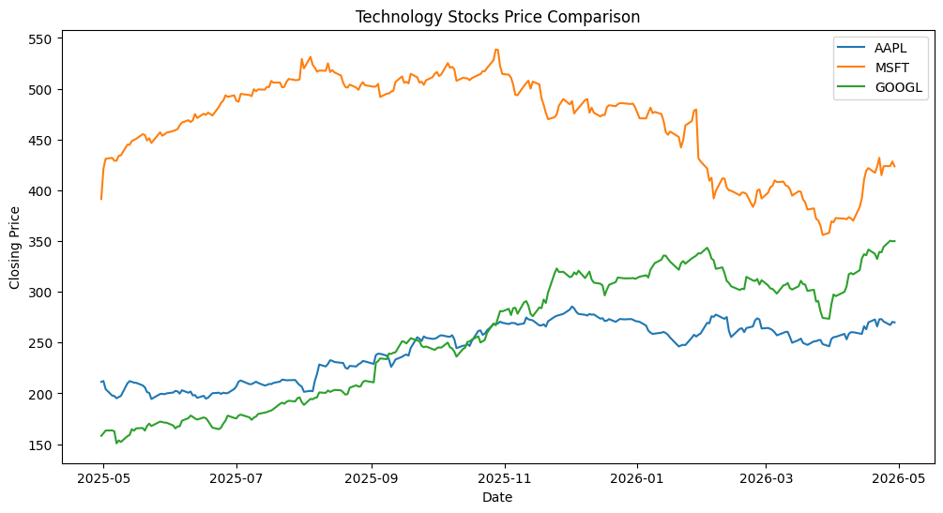

4. CORRELATION ANALYSIS
Correlation Heat Map Using Stock Returns for Apple, Microsoft and Alphabet on a Daily Basis
Observations
The stocks were weak to moderately correlated for the chosen period of time. The stocks of Apple and Alphabet had the highest correlation value while Microsoft was comparatively less correlated with other two stocks.
Interpretations
Despite belonging to the technology sector, there was no perfect correlation among the stocks of all three firms for the chosen period of time. This is because each company has its own set of strengths, weaknesses, and market performance.
These findings imply that diversification can help investors even within the same sector.
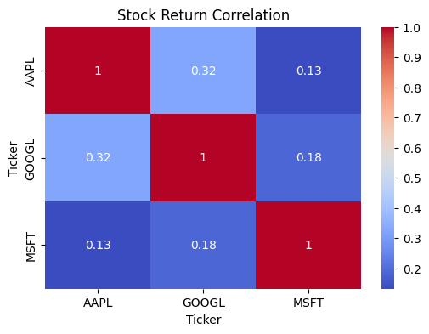

5. VOLATILITY ANALYSIS
Rolling volatility was estimated based on the 10-day moving standard deviation of the daily returns.
Observations
For the year under study, the volatility of Microsoft spiked the most at the beginning of 2026, whereas Alphabet saw several instances of volatility spikes as well. The company that demonstrated comparatively smooth volatility is Apple.
Interpretation
The higher volatility for the stocks of Microsoft and Alphabet could be attributed to investors' responses to information related to their earnings reports or advances in artificial intelligence.
In the case of Apple, the smoother volatility indicates relatively stable investor sentiment during the specified period.
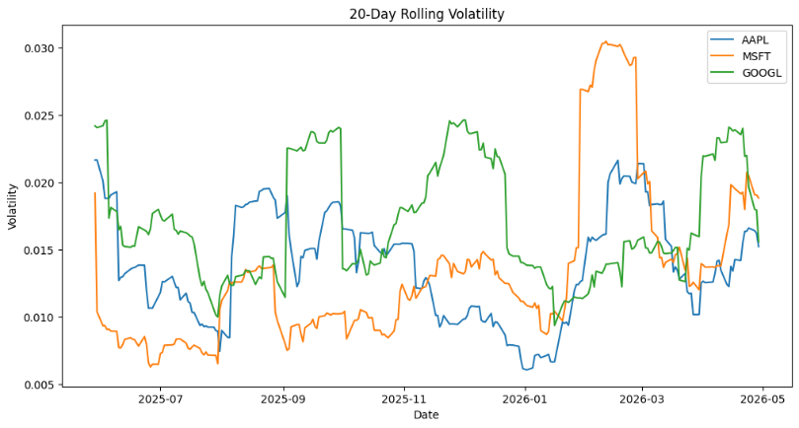
6. MOVING AVERAGE TREND ANALYSIS
Microsoft stock price was analysed using a 10-day moving average in order to determine short-term trends and momentum behaviour.
Observation
Moving averages were able to effectively show trends in the short term because they smoothed out the day-to-day changes in the prices. There appeared to be some periods where there were upward or downward trends which were not readily identifiable otherwise.
Interpretation
Moving averages might be useful tools for identifying momentum trades and potential trend continuation or reversals.
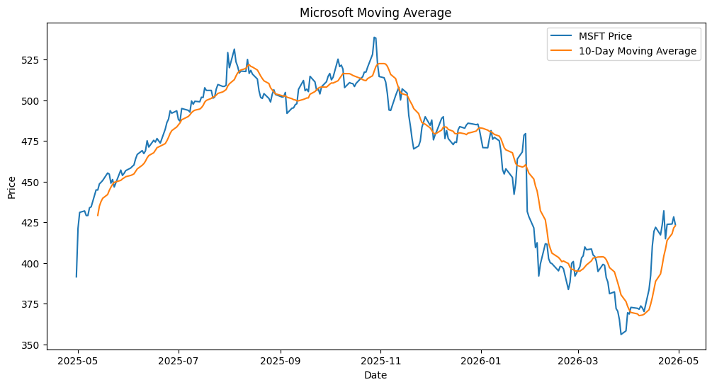

7. TRADING STRATEGY IDEA
Momentum Based Trading Strategy
A basic momentum based strategy has been built using the shares of Microsoft.
Strategy Rules
Buy when the stock price exceeds its 10-day moving average.
Sell when the stock price dips below the moving average.
Volume in addition was used for confirming the trend.
Rationale
The main intention of this strategy is to capture the uptrend momentum. Trend-following strategies are often preferred because they offer simple and easy-to-understand trading signals.
Here, we do not try to make aggressive profits but only determine if basic momentum indicators can be effective in finding good markets.
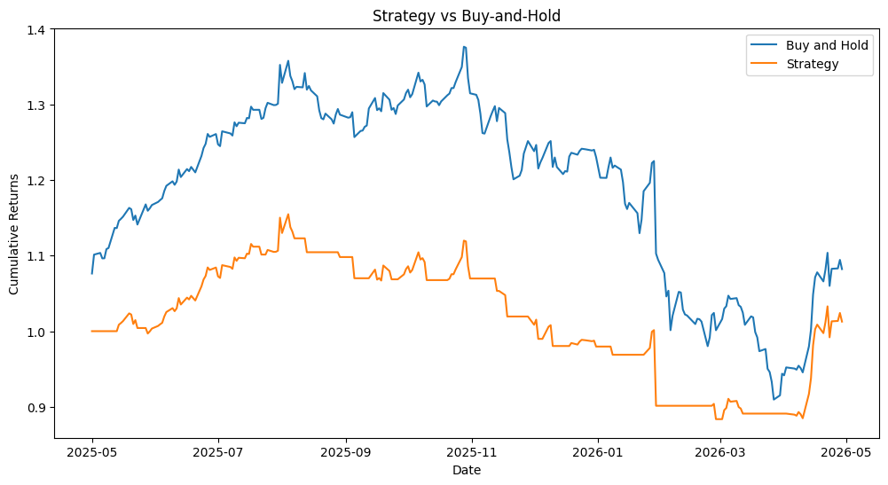
9. VOLUME ANALYSIS
The volume analysis was done with the aid of Microsoft volume data along with a 10-day average volume oscillator.
Observations
A number of instances where there have been higher volumes than normal have been observed especially in early 2026. These have correlated with periods of higher market activity and volatility.
Analysis/Interpretation
Higher trading volumes could be an indication of increased participation in the market. Volume analysis can help us confirm market trends in progress.
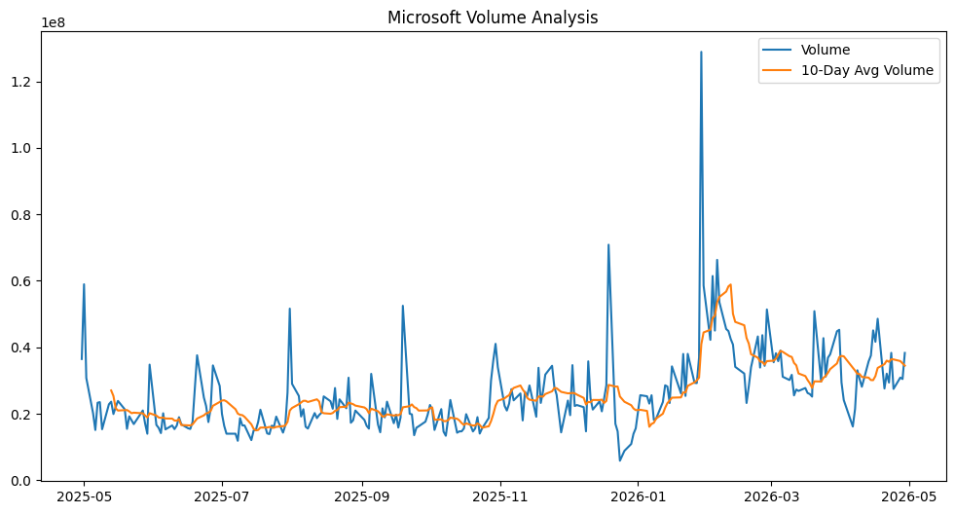
10. RISKS AND WEAKNESSES
Despite providing useful results, the following limitations and risks need to be kept in mind.
1. Limited Market History
The market history used in this analysis is just for one year, and hence, it does not reflect long-term market cycles and extreme market situations.
2. Wrong Indicators of Trade
Trading indicators may provide false signals in case of market consolidation or high market volatility.
3. Market Sensitive
This market is sensitive to many factors such as sentiment, earnings release, macroeconomic factors, and any technological innovation.
4. Cost Inclusion
Continuous trading operations can result in low gains because of transaction costs in reality.
5. Risk of Overfitting
Overfitting means a technique that works on past data may not work for future market conditions.

11. CONCLUSION
The project involved analysing historical data on equities of large tech companies like Apple, Microsoft, and Alphabet through analysis based on price, returns, volatility, and volume.
The study revealed that there was weak to moderately strong positive correlation in the tech industry, distinct behaviour of short-term volatility, and significant connections between trading volumes and market activities.
A momentum strategy that utilizes moving averages was introduced and tested for conceptual purposes using historical prices of Microsoft shares. The momentum strategy proved to have effective defensive aspects in weak market conditions, while the buy-and-hold strategy earned higher cumulative gains.
This project is an illustration of how financial data analysis can provide valuable market insights, test investment strategies, and analyse risk behaviour.
12. AI USAGE STATEMENT
AI tools were used to assist in structuring the report, refining explanations, and validating the analysis process. My observations, interpretation of results, and strategy explanations were revised by me to clarify meaning and ensure accuracy.

